04.04 Approval Control
Process Design & AMOS Configuration Document
Purpose

Revision
Author, Name | Date | Notes
Jakub Sadowski | 01.12.2024 | Edition 24.12 – visual improvements only

Table of Contents
1. Process Overview & Objectives 3
2. Regulatory References 3
3. Definitions & Glossary 3
4. Process Tasks 3
5. Process Dependencies 3
6. Process Flow 4
7. Process Design Questions 5
8. Data Source Mapping 6
9. Other Software Used 6
10. AMOS Configuration 7
a. Process specific configuration programmes 7
b. Basic Data 7
c. Parameters 8
d. Workflows 9
e. Scheduled Tasks 9
f. API’s & Interfaces 9
11. UAT Guidance 9
12. Annex – Additional Info 10

Process Overview & Objectives
Process General Description:
Approval Control allows limiting certain outputs of other AMOS processes to be only released/valid after other users allow it (give Approval).
Main Process Objective (Outputs & Outcomes):
AMOS environment configured in a way, which does not allow documents/orders/modifications to be processed without an approval or chain of required approvals.
Approval requests communicated via e-mail or AMOS mail using automatically triggered Workflows.

Regulatory References

N/A

Definitions & Glossary
Key-Words | Explanation
Rules | The logic used by AMOS to trigger an action in AMOS in accordance with the business requirements
Parameters | Values that can be added by the user in the rules

Process Tasks
Approval Flow: Requesting Approval – employee involved in input processes requests necessary approvals after certain outputs are ready to be assessed and approved by
Approval Flow: Granting Approval – designated person or group of persons approve the requested entity in AMOS, allowing outputs of other processes to result in completion.

Process Dependencies
INPUT | CONCURRENT | OUTPUT
00.02 AMOS Users & Roles  01.04 Maintenance Programme  02.05 Technical Library  03.04 Modification Campaigns  08.02 Performing Maintenance  09.04 Ordering  12.03 Invoice Checking  12.04 Customer Quotations and Billing |  | 01.04 Maintenance Programme  02.05 Technical Library  03.04 Modification Campaigns  08.02 Performing Maintenance  09.04 Ordering  12.03 Invoice Checking  12.04 Customer Quotations and Billing

Process Flow
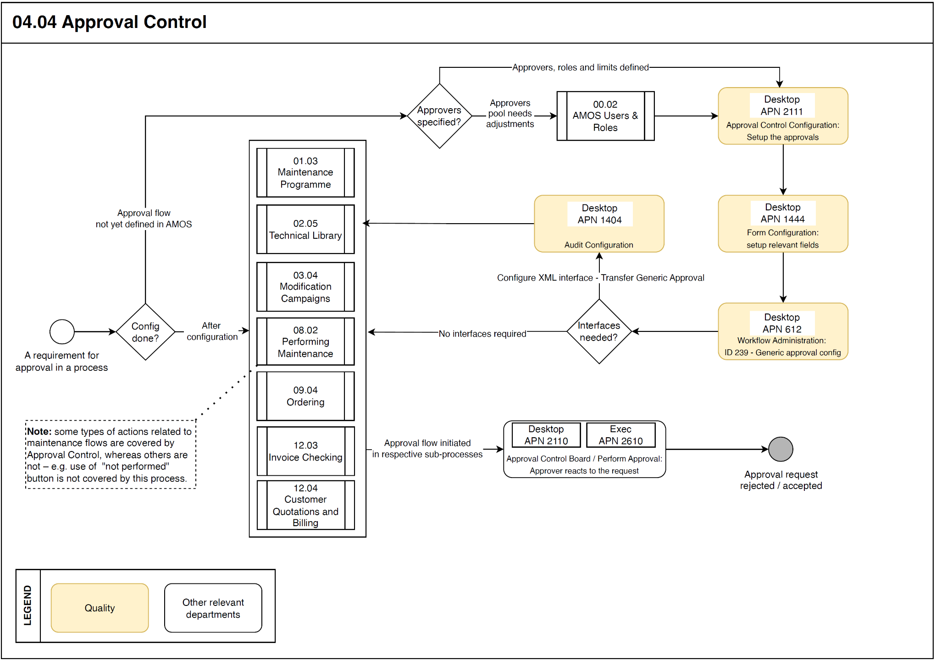

Process Design Questions
# | Question | Answer
 | What approval processes you have currently in your company?
 | Are your approval processes paperless?
 | Would you consider using AMOS for your approval management? If not, why?
 | How the approval control works in your company?
 | Which actions are generated in the approval process in your company?
 | Are there situations when a normal approval chain must be bypassed?

Data Source Mapping
Data Sources | Description | Volume / Manual / Automatic / Static / Dynamic
-/- | -/- | -/-

Other Software Used
Other Software | Used by: | Description
-/- | -/- | -/-

AMOS Configuration

Process specific configuration programmes
AMOS APN | Notes
APN 612 Workflow Administration | Used to inform other users on new approval requests, as well as stopping processing of certain non-approved entities by use of Conditional Stop
APN 1404 AIM Configuration | Used when interfacing other applications is required (Transfer Generic Approval)
APN 1444 Form Configuration | Allows to restrict visibility relevant fields in AMOS forms or to make some of them mandatory
APN 2111 Approval Control Configuration | Defines Rules for Approvals and approval chains (who should approve)

Basic Data
Basic Data Table | Notes
Additional State | An Approval can be "flagged" with an additional state, which can be defined in this table. This state will be available when re-/assigning an approval to somebody else, so the recipient knows how you`ve classified the approval.
Approval Report Definition | In the Approval Report Definition table Reports available in Report Designer with corresponding ID are defined here with the according description.  These Reports can be set when a new Authority Configuration is created depending on the program the Authority Configuration is implemented the report is automatically chosen if available (At the moment only supported in Occurrence Reporting)
Approval Type | Table to define the Approval Types which indicates the various approvals. In general, approval types are split into internal (in-house, managed) and external organisations. Internal means that the approved activity is executed with AMOS, such as in-house maintenance or internal shops.  External approvals are used to control external organisations and record activities which have been performed outside of AMOS (external maintenance provider, external repair shop).

Parameters
Parameter Code | Parameter Name | Notes
1440 | Use Order Approval Logic | This parameter gives the possibility to activate/deactivate the Approval Control in Order Management 2 (APN 2015) via the String value.  Integer value determines if an approval report should be created automatically when an approval is created. This should be set to "0" so as not to slow down the approval process.  If Float value is set to 100.00, all approval relevant fields will be disabled for all invoiceable order types as soon as an invoice exists for the order. This should be set to "0.00" so that the AP know that they should not process the invoice in the event the relevant orders are not approved.
1605 | Activate Billing Approval | This parameter gives the possibility to activate/deactivate the Approval Control in Billing (APN 196) via the String value.
1610 | Activate Invoice Approval | This parameter gives the possibility to activate/deactivate the Approval Control in Invoice Checking (APN 307) via the String value.
1666 | Activate Approval Control in View/Edit Modifications | This parameter gives the possibility to activate/deactivate the Approval Control in View/Edit Modifications (APN 63) via the String value.
1667 | Activate Approval Control in Publication Management | This parameter gives the possibility to activate/deactivate the Approval Control in Publication Management (APN 565) via the String value.
1668 | Activate Approval Control in Engineering Orders | This parameter gives the possibility to activate/deactivate the Approval Control in Engineering Orders (APN 852) via the String value.
1719 | Enable/Disable Approval control in Maintenance Program Administration | This parameter gives the possibility to activate/deactivate the Approval Control in Maintenance Program Administration (APN 249) via the String value.
1720 | Enable/Disable Approval control in Operator Maintenance Program | This parameter gives the possibility to activate/deactivate the Approval Control in Operator Maintenance Program (APN 1934) via the String value.

Workflows
Workflow Number | Workflow Name | Workflow Setup Notes
239 | Generic Approval | This workflow is triggered on requesting or changing an approval request.

Scheduled Tasks
Scheduled Task Reference | Frequency | Notes
N/A | - | -

API’s & Interfaces
Reference | Direction | Trigger | Frequency
Transfer Generic Approval

UAT Guidance
Test case number | Test case description | Required data | Required resources
T04.04.01 | Check the process of issuing any object requiring Approval Control with a designed approval chain
T04.04.02 | Check the process of issuing any object requiring Approval Control using approval by-pass (if forseen)

Annex – Additional Info

Default approval control
Name | Description | Type
Close Bill | Triggered when a Bill is closed | Document to be approved from financial perspective (used when an order is modified)
Close Invoice | Triggered when an Invoice is closed | Document to be approved from financial perspective (used when an order is modified)
Document | Triggered when an approval is requested | Document to be approved without specific subject
E.O. | Triggered when an approval is requested | Document to be approved without specific subject
Issue Order | Triggered when an order is issued | Document to be approved from financial perspective (used when an order is modified)
Maintenance Program Revision | Triggered when an approval is requested | Document to be approved without specific subject
Maintenance Program Task Revision | Triggered when an approval is requested | Document to be approved without specific subject
Mat. Alloc. Creation | Triggered when an unavailable part is linked | Document to be approved without specific subject
Modify Order | Triggered when an order is modified | Document to be approved from financial perspective (used when an order is modified)
Occurrence Report processing | Triggered when an Occurrence Report is processed. | Document to be approved from legal perspective
OMP Revision | Triggered when an approval is requested | Document to be approved without specific subject
OMP Taskcard Revision | Triggered when an approval is requested | Document to be approved without specific subject
Process Entity Transaction | Triggered when an entity transaction is executed | Document to be approved from financial perspective (used when an order is modified)
Publication | Triggered when an approval is requested | Document to be approved without specific subject
Publish Quote | Triggered when a quote is ready to be published to a customer | Document to be approved from financial perspective (used when an order is modified)
Release Budget | Triggered when a budget is released | Document to be approved from financial perspective (used when an order is modified)
Request Customer Mailing approval | Triggered when a Customer Mailing approval is requested | Document to be approved without specific subject
Sandbox Technical | Triggered when technical approval is requested | Document to be approved from technical perspective
Workorder | Triggered when technical approval is requested | Document to be approved from technical perspective

